CONCEPT NOTE
for the
Matching Fund PRO-PLANTEURS
04.06.2020
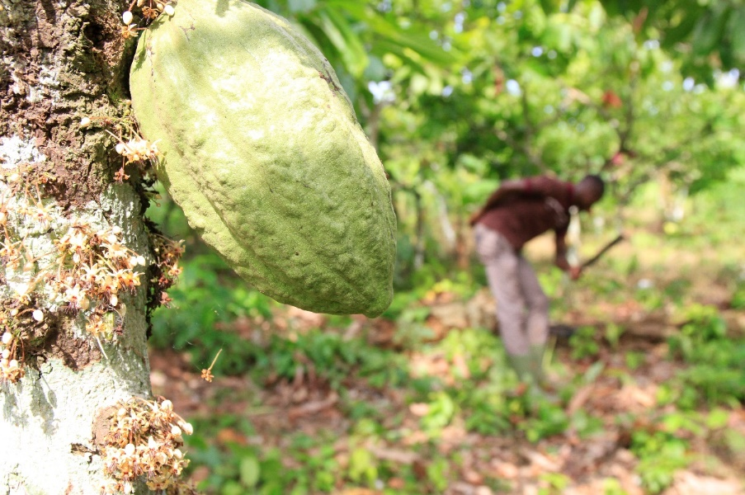
This document is based on the application format for PPP projects financed by the BMZ.

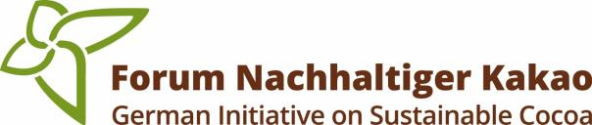
PRO-PLANTEURS is a joint project of
To be filled out by the implementing organization (IO):

Project Title:

Country: |  | Estimated duration of project:
Region:

Presented by: | Name of the organizations presenting the project idea
Contact person: | Main contact person, telephone, e-mail…

Estimated project budget
Project total budget | EUR
Contribution of the applicant(s) | EUR
Contribution of the Matching Fund | EUR
Planned third-party contribution  (if relevant) | EUR

General Information:
Please adhere to the given space limits when preparing the project idea and use the key questions in the description for orientation.

Be as specific as possible in order to simplify the assessment of your project idea.

Additional information on the assessment criteria can be found in PRO-PLANTEURS Matching Grant Fund concept document.

Proposals will be accepted in English.

Please send the project concept as a Word document stating the subject project concept Matching Fund PRO-PLANTEURS (company / companies), (country / countries) by the deadline to elvis.core@giz.de. Please also attach the declaration of commitment as signed scan to your e-mail.

The information provided in
Chapters 1 – 4 should not exceed 3 pages in total

Project stakeholders

Brief description of the organizations presenting the joint project idea

Brief description of other organizations and stakeholders involved in the project idea

The context – problem analysis

Briefly explain, in a layperson's terms, the key development challenges the project idea is addressing

Project idea - objective, indicators, target group, activities, outreach

Briefly describe the concept of your project idea
- What is the projects objective? (project objective)
- What are the key results of the project? (indicators) name 2 – 3 indicators (quantify as far as possible)
- What activities will be carried out to achieve the objective and results? (activities)
- Who is the target group? How big is the target group?
- Where in Côte d’Ivoire will the project be carried out?

Expected contribution from GIZ

Briefly explain, what kind of contribution you would request from GIZ

Contribution to the objectives of PRO-PLANTEURS and GISCO

Briefly explain to which objectives of PRO-PLANTEURS and GISCO the proposed project will contribute

PRO-PLANTEURS´ objectives

PRO-PLANTEURS´ OBJECTIVES | Contribution of the project to the objectives of PRO-PLANTEURS
Producer families in the project area improve their socio-economic living conditions and contribute to the conservation of natural resources.
Strengthened producer cooperatives provide services to their members, including measures against child labor.
Professionalized agricultural producers, who are member of cooperative societies, have improved their skills as entrepreneur and are applying practices of sustainability and agricultural diversification
Enhanced cooperation between actors of the cocoa value chain promote synergies for the benefit of all participants, through integrated projects.
Knowledge management and exchanges between the actors in the value chain contribute to the dissemination of good practices and innovative approaches.
GISCO´s objectives

German Initiative on Sustainable Cocoa Objectives | Contribution of the project to the objectives of GISCO
To improve living conditions of cocoa farmers and their families and to contribute to a secure living.
To conserve and protect natural resources and biodiversity in cocoa producing countries.
To increase cultivation and commercialization of sustainably produced cocoa.
The German Initiative on Sustainable Cocoa pursues advocate for:
1. improved farm-gate prices, minimum price and premium systems as well as other income-generating measures as contributions to a living income (1) of cocoa farming households.
2. improving the productivity of cocoa cultivation and the quality of cocoa.
3. supporting governments and other stakeholders in the development of holistic regional agricultural programs in order to create alternatives to cocoa cultivation and thus counteract overproduction.
4. promoting the development and use of sustainable and diversified production systems, in particular agroforestry systems, which conserve natural resources as well as ending the application of hazardous(2) and/or unauthorized pesticides.
5. ending deforestation and contributing to conservation of forests and biodiversity, and to reforestation.
6. the abolition of worst forms of child labor in cocoa production.
7. the enhancement of gender equality and improvement of opportunities for women and young people in the cocoa sector.
8. enforcing compliance with human rights (implementation of the UN Guiding Principles on Business and Human Rights) and environmental aspects by all actors in the cocoa supply chain and contributing to the discussion on possible regulatory measures at EU level.
9. the strengthening of governments, farmer organizations and civil society in the cocoa value chain in the producing countries.
10. the entire cocoa in cocoa-containing end products sold in Germany to come from sustainable cultivation in the long term.
11. a share of at least 85 % of cocoa in cocoa-containing end products sold by the producing members in Germany to be certified by sustainability standards or to be equivalently independently verified by the year 2025.
12. promoting multi-stakeholder partnerships and collaboration for more sustainability, networking, sharing information and experience, learning from each other and reporting on progress in achieving objectives and applying best practices.

Funding principles: Commercial partners: 50% Matching Fund Grant & 50% GISCO member(s) Non-profit partners: 75% Matching Fund Grant & 25% GISCO member(s)

